**18-240 Lab3b Final Lab Report**

**Ram Verma (ramv), Charly Cai (qcai) Section A**

**Overview**

The objective of the lab was to create the game ‘breakout’ using Verilog. Thus, we had to utilize different Verilog modules for different parts of the game and have them all update and reset at them at the same time through the use of a common clock.

Each block would handle a certain part of the game; such as the ball, paddle or bricks since these values change as the game progresses. There was another paddle that handled the continuous updates and produced the color output as well as the wall output.

The last module was the chipInterface which took the module handling all the updates and connected the outputs to the wires on the board.

**System Schematic (same as prelab)**

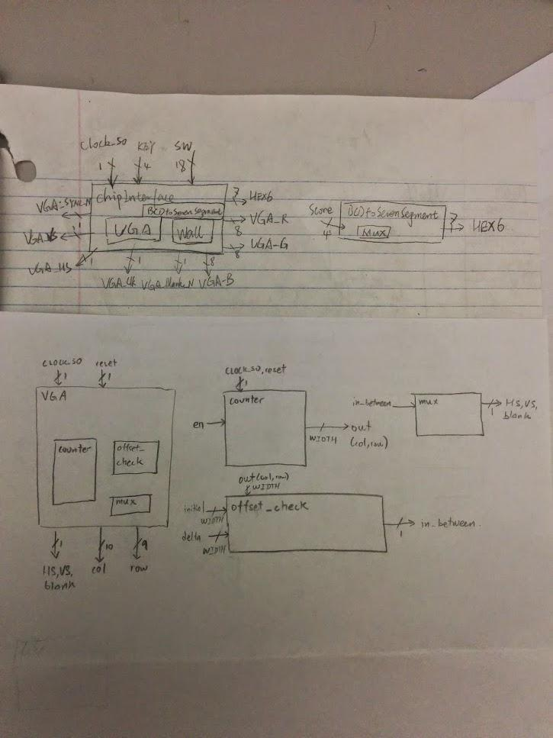

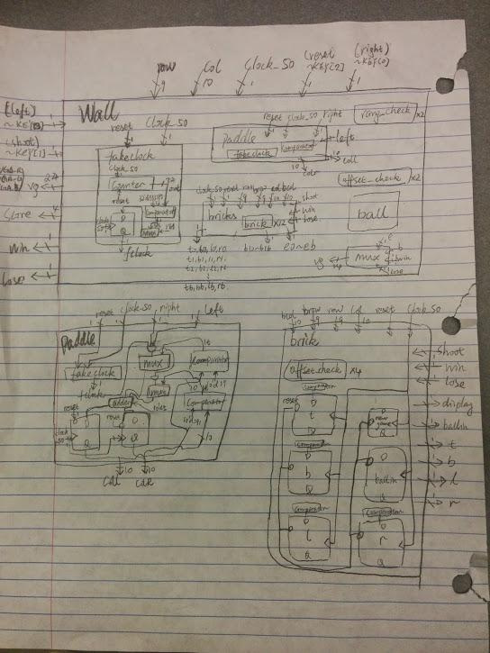

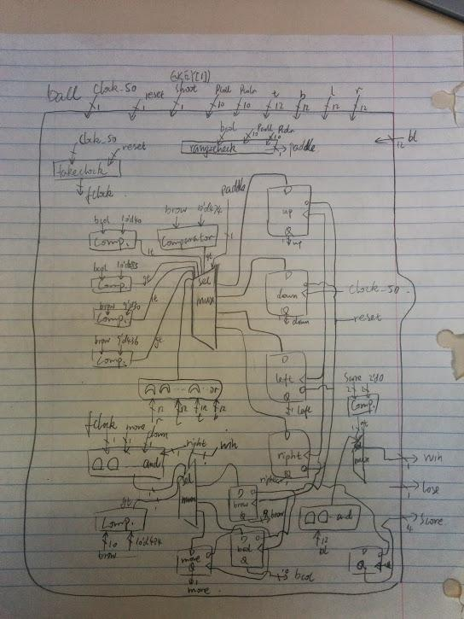

**System Level Diagram**

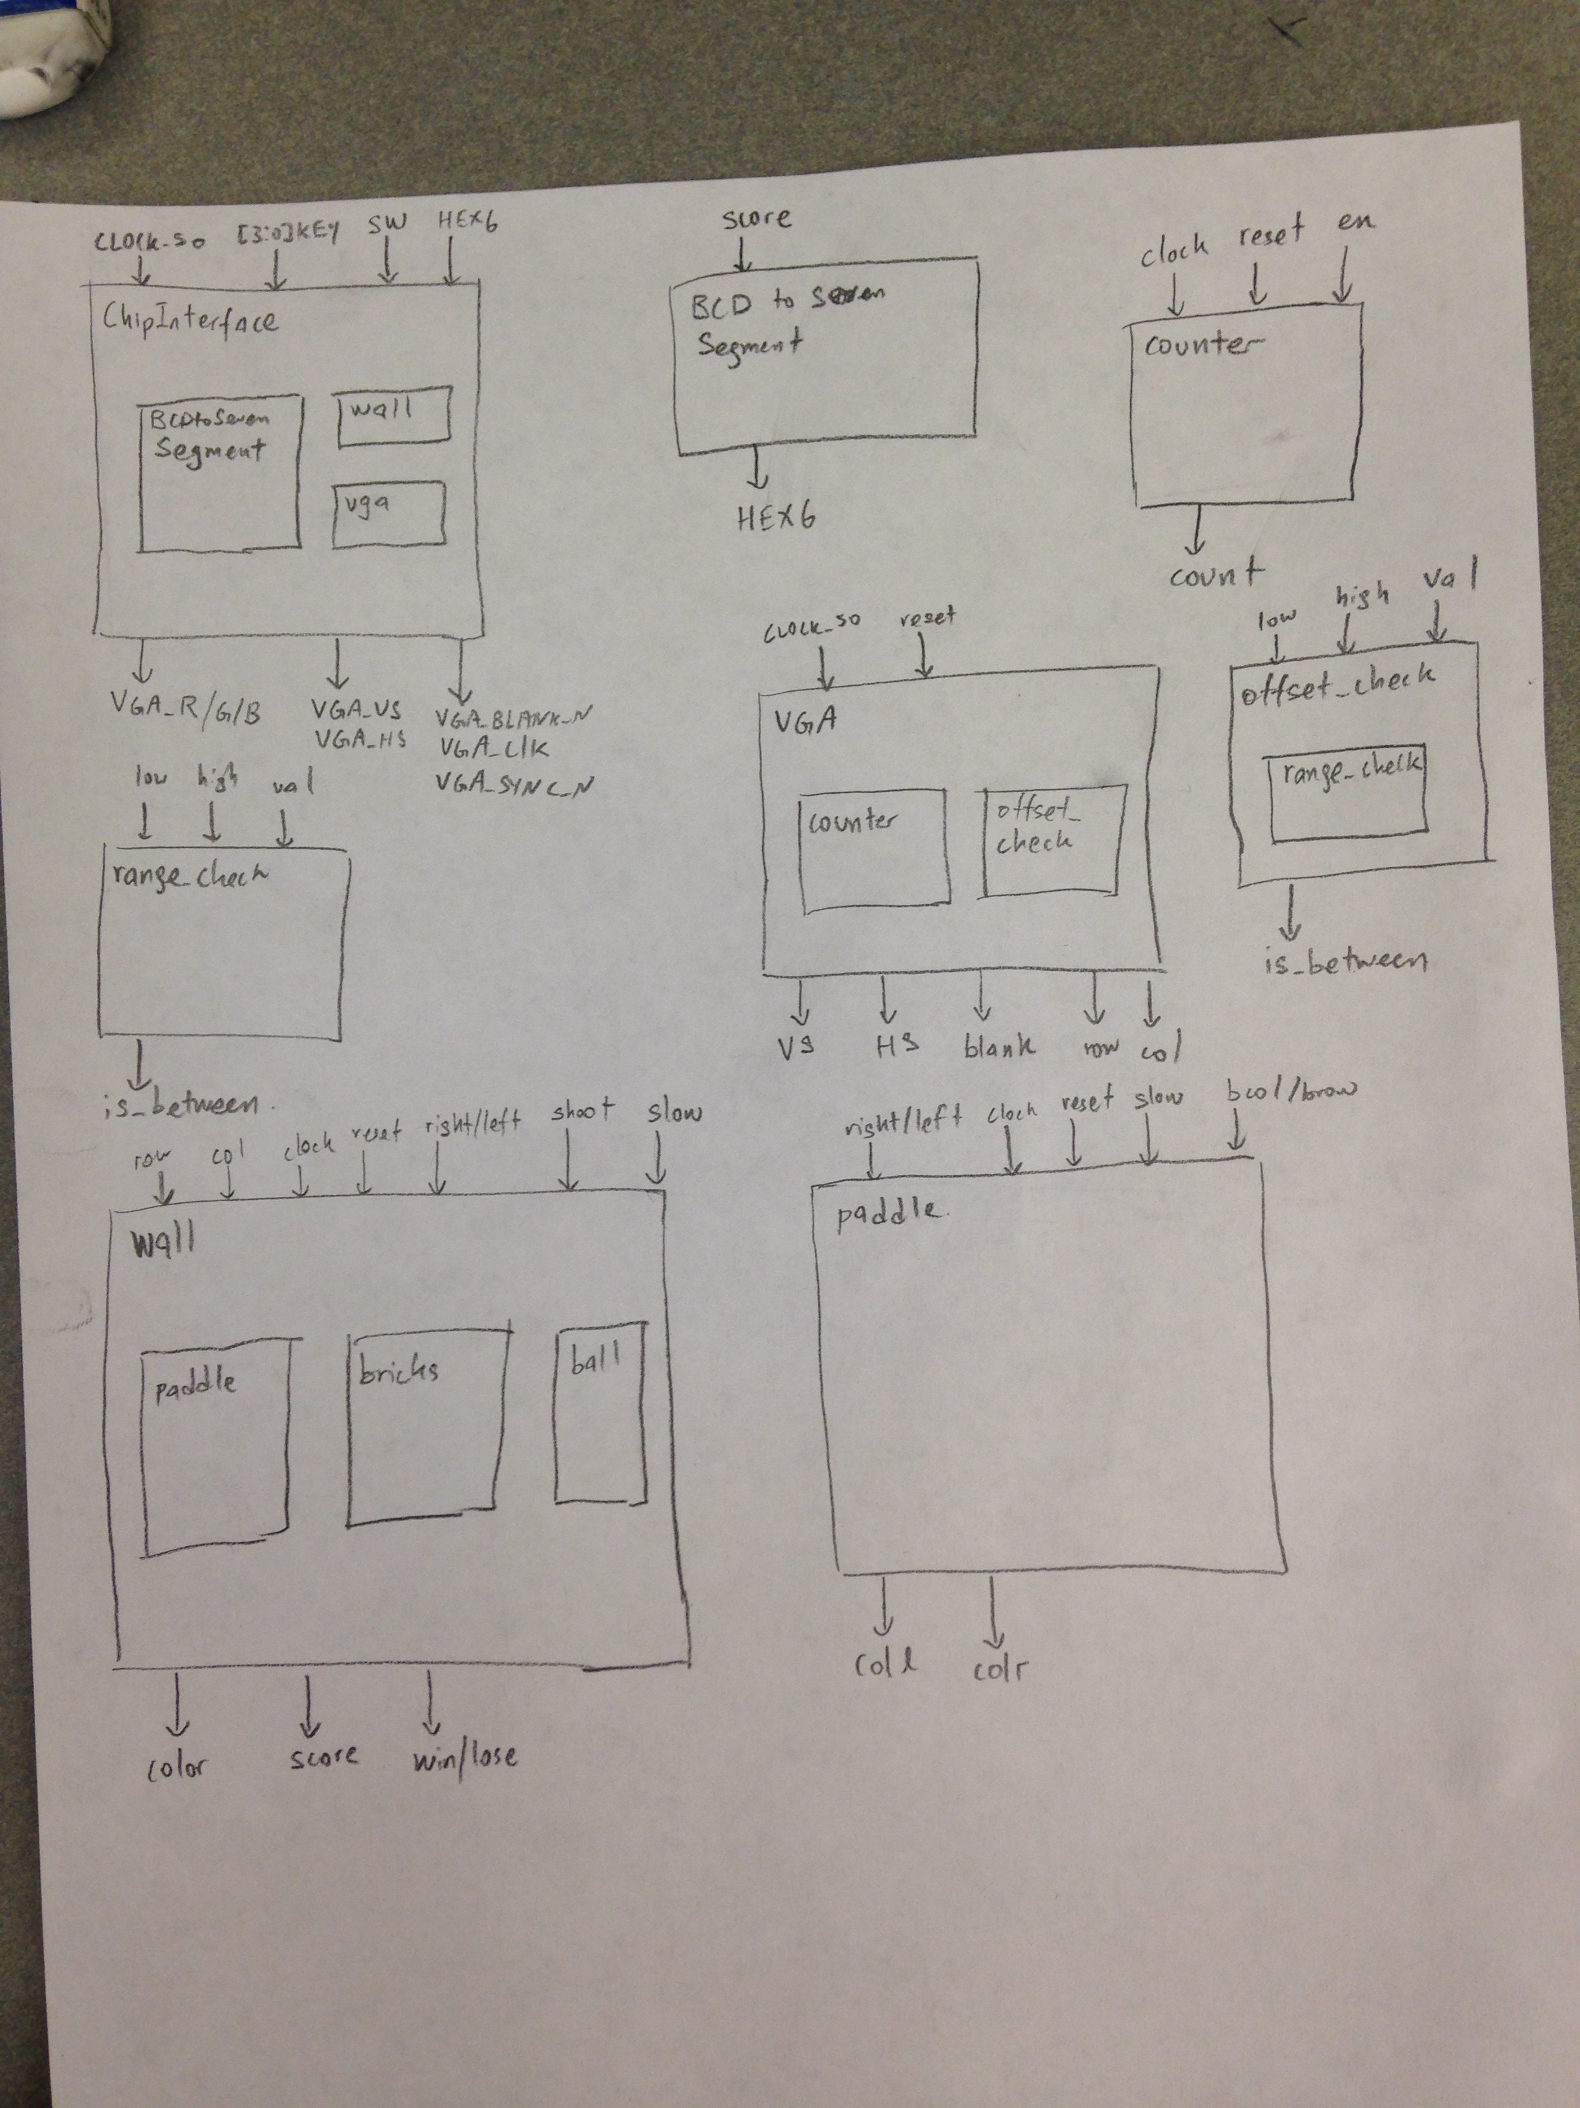

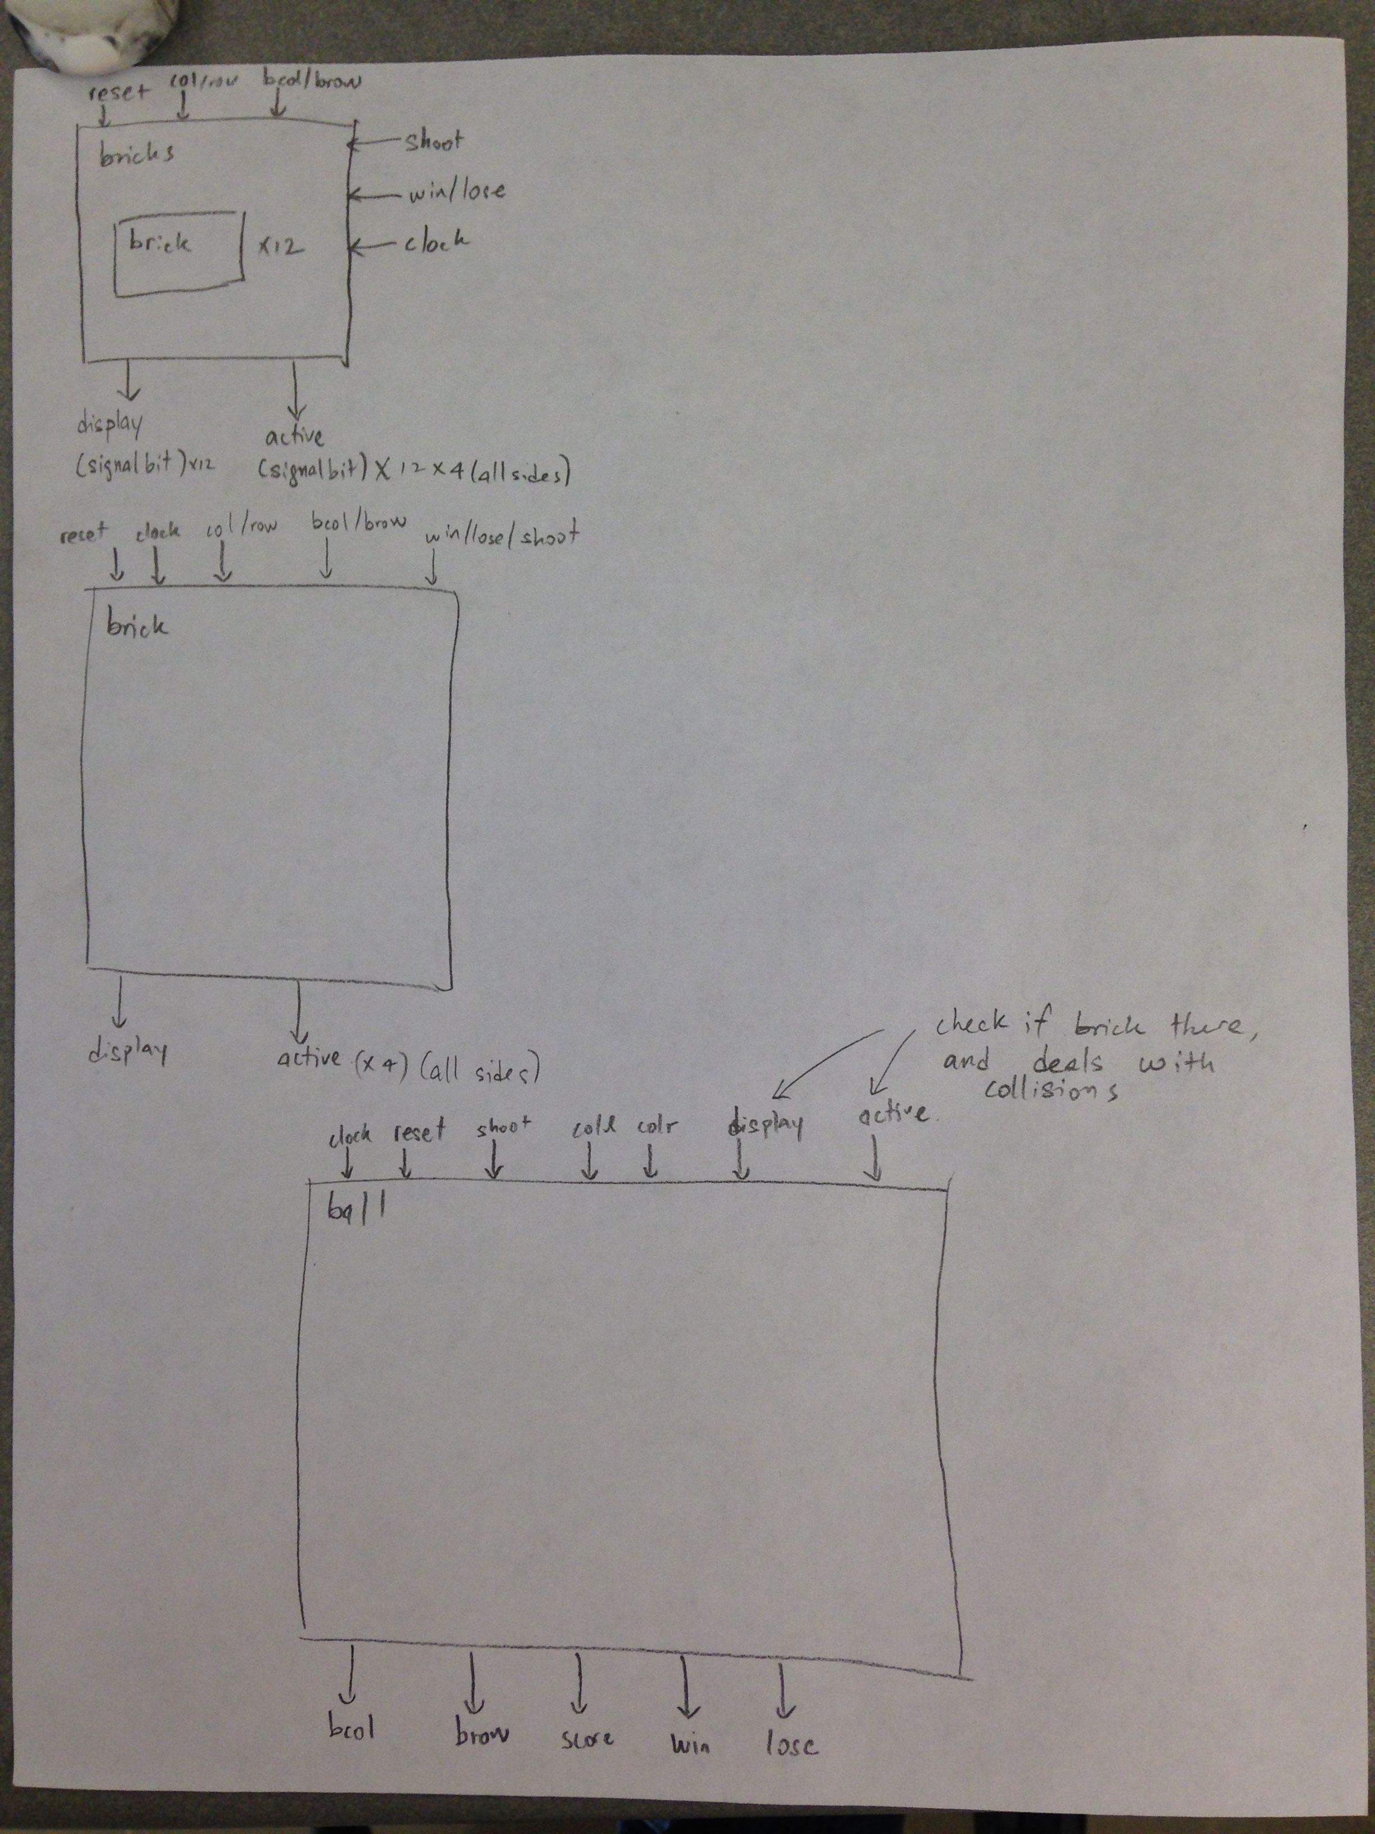

**Module Explanation**

Wall (main module):

This module takes in row, col, clock and some other standard inputs and outputs the color at the specific row and col, the score and the movement speed.

This module calls the other modules and also always outputs the color of the walls based on the game condition (win, lose, playing).

Paddle:

Takes in input of the initial position of the paddle, and based on the input of either going left or right, shifts the position of the paddle; which is also the output of the paddle (the left and right coordinates of the paddle).

Bricks:

Calls multiple instances of the module brick at different positions to get all the 12 bricks.

Brick:

Take in position of the top right of the brick, and outputs the row and col in which there is a brick It also outputs whether the brick should be displaying and whether the ball has hit the brick (once hit this value is remembered and stays at one).

Ball:

This module handles all ball collisions and changed direction and velocity of the ball based on different collisions. It takes in the position of the paddle to know if it collides with the paddle, and also the 1 bit value of each brick to check if the brick is active, and therefore collide with the brick.

ChipInterface:

This is the module which wires up the board by calling the main module as well as the BCDtoSevenSegment display. It also sends all the VGA outputs for the monitor display.

**Simulation Results**

For the two comparator modules (range_check an offset_check), we wrote testbenches to make sure these components were working before we proceeded.

Secondly, for the vga module, we had the display print out the eight color combination both horizontally and vertically to make sure there were no errors in the col and row output since these were the inputs for the later modules.

With the vga module done, the way to simulate the other components (which had an always_ff block each) was by displaying it on the monitor and visually verify the module was doing what we wanted it to do.

**Discussion on Simulation Result**

The results of the simulation(testing on the monitor display) showed when the ball overlapped one of the other components or there was an off by 1 error due to the input values.

**Discussion on Testing Strategy**

The testing strategy was basically playing the game after every small update or change and trying to find glitches by going through every possible state of the game (different game scenarios).

**Write a short paragraph (quarter of a page or so) and try to explain the fundamental differences in writing the hardware description you wrote and software description you thought about. Why does a language like SystemVerilog exist?**

Modern programming language such as Java and C and etc. are more abstractive. They have memory modules built in, which allows them to perform state changes in a more intuitive way. Programming language is more close to human language. However, it needs al lot of help to compile in order for computers to understand. System Verilog is more computer friendly because it traces the combinational logic changes and gate level manipulations. Compared to programing language, System Verilog is more difficult for human to understand. We need preassigned tables and assignments in order to define a sequence of operation. Like C, System Verilog directly manipulate the memory of computer. In a more advanced way, System Verilog also allows users to design gate level operation, creating their own circuit for specific tasks. In general, the operating speed on hardware, designed by System Verilog is faster than the software programed in C or other languages.

**How many FSMs did your final design (synthesized version) include? List them. How is designing this circuit as a hardware thread different from attempting the same project as a single FSM?**

In breakout.sv:

Ball: 2 FSMs, one used for outputting collision positions; another one is used to output ball position.

Brick: 1 FSM, used to determine bricks to display and collision with ball.

Paddle: 1 FSM to output the position of paddle.

Wall: 1 FSM to determine the color of each pixel in row and column.

In ChipInterface.sv:

No FSMs. This module has combinational logic that wire different module together.

In Task2.sv:

2FSMs. One for vga module. The module uses counters to calculate the pixel. The output is a VGA wave signal generated by combinational logic based on different states. A second FSMs is simply used to count the row and column and output them as they are. The FSM reset after reaching the limit of row and column.

In Task1.sv:

No FSMs, all combinational logic.

We have used 7 FSMs in total. Designing as a hardware thread helps spreading the work. For programmer, it is better and more intuitive. It is also much easier to debug and understand what the code is doing. Separating into different thread helps to simplify the states. If we were doing in one single FSM, there could be a big number of states we have to define. There wouldl be a lot of edge cases that we have to consider as programmers. Additionally, the combinational logic for output and next state logic would be overly complicated, which is super hard for programmers to synthesize and debug.